1. Ping another computer

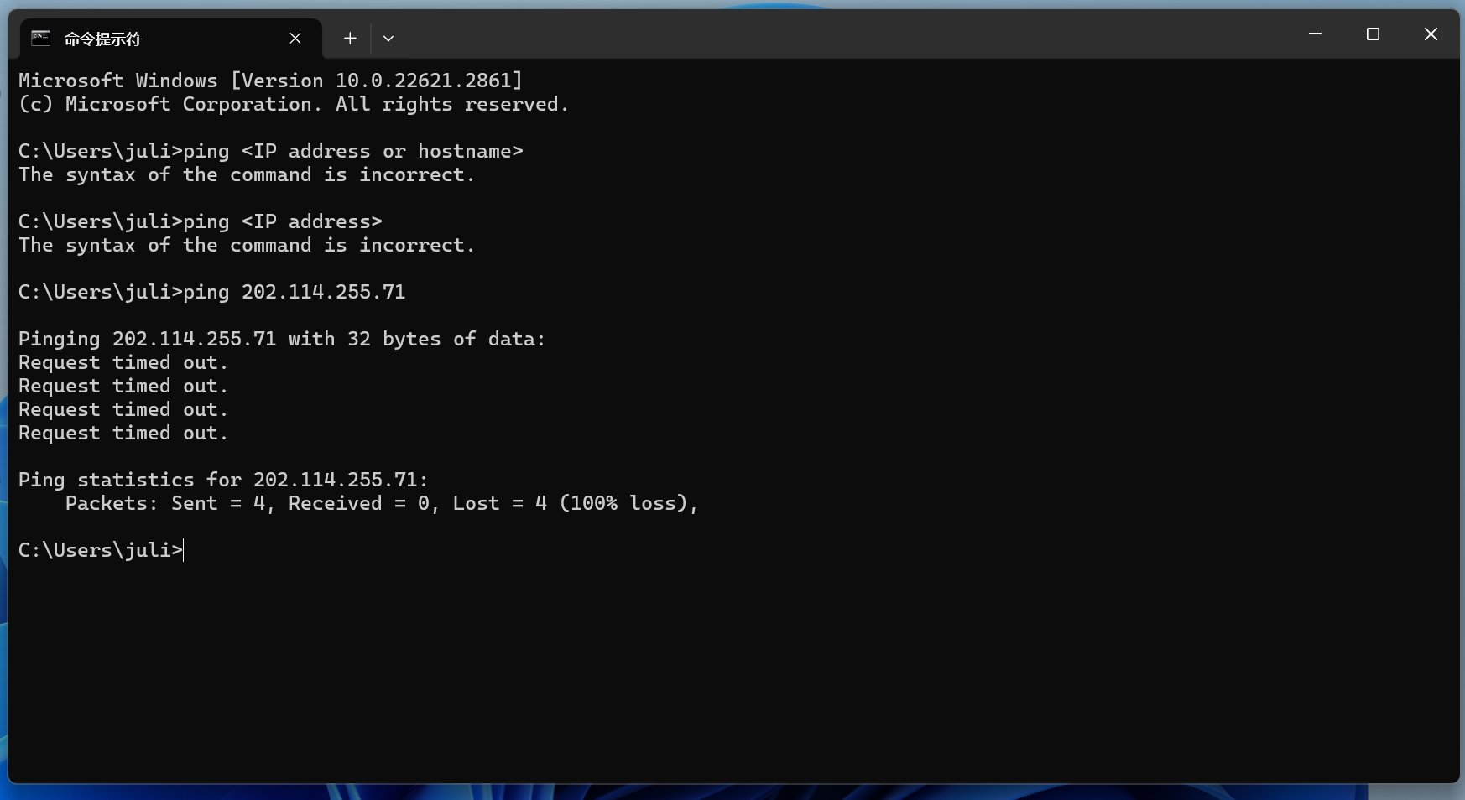

The computer did not receive any responses within the expected time frame. Each "Request timed out" message indicates that no response was received from the destination within the specified timeout period.

The "Ping statistics" section summarizes the outcome:

* "Packets: Sent = 4" indicates that your computer sent out four ping packets.
* "Received = 0" indicates that none of these packets were received back.
* "Lost = 4 (100% loss)" means that all four packets were lost, indicating a 100% loss rate.窗体顶端

1. tracert a server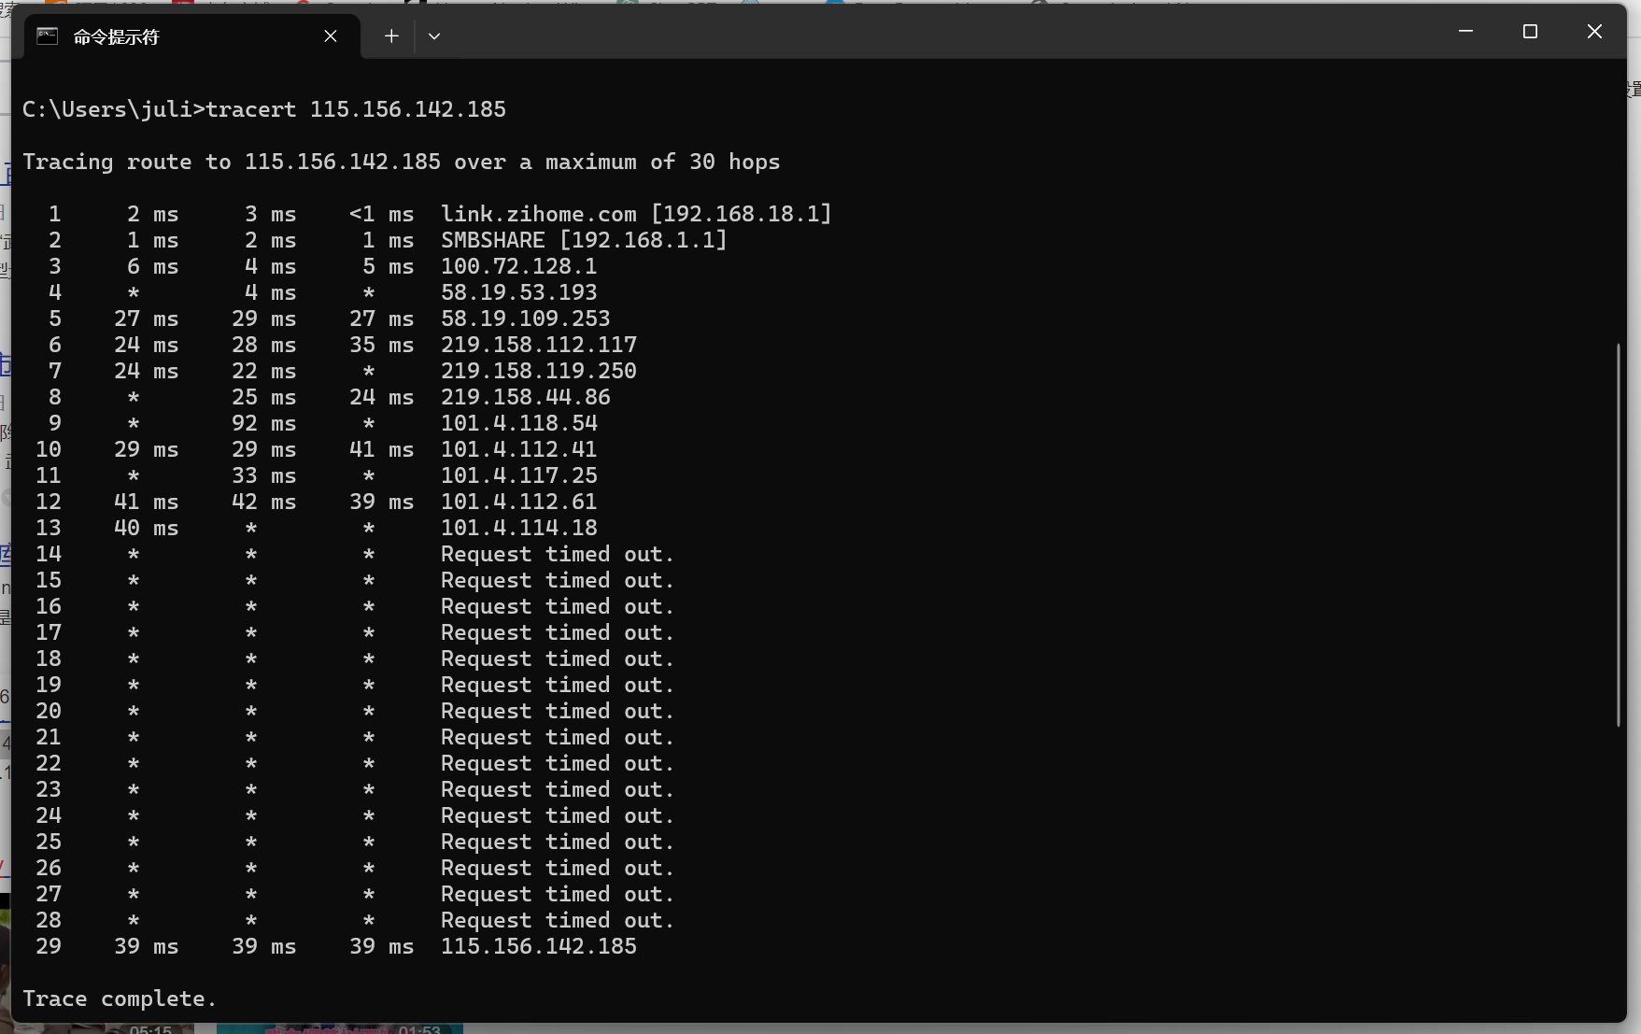
2. register a github account, download lab resource from https://github.com/wireshark/wireshark

